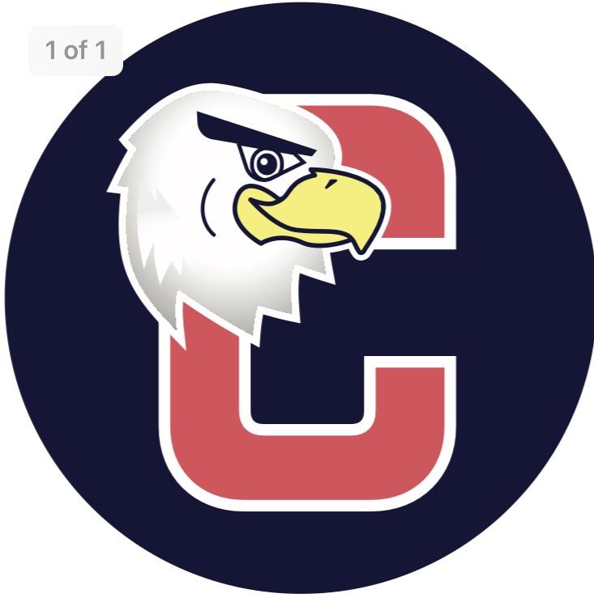
Cucinella PTO
General Membership Meeting Agenda
Monday, December 20, 2021

- Call to order
- Acceptance of Meeting Minutes from November 15, 2021
- Reports:
- Principal/Vice Principal Report

- Presidents Report
  - Treasurer report

- Treasurer

- Secretary

  - Winter Teacher Appreciation

- Communications

- Membership

- Fundraising

- Programs

- Room Parent

- Old Business
  - Sensory Hallway

- New Business

- Adjourn

