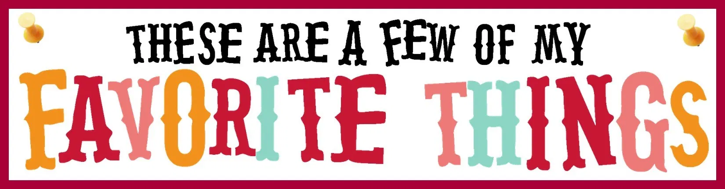
Please share with us some things you love and things you hold dear,
so that we can shower you with “surprises” throughout the year!
Your name:________Ellen Mazzei_______________________________________________
Do you have any allergies?___No_______________________________________________
Favorite Drink (Soda, Coffee/Tea): _____Starbucks Frappucino_______________________
Sweet treat: ____Carrot Cake__________________________________________________
Salty treat: ___Popcorn_________________________________________________
Restaurant: ____The Chesapeake______________________________________________
Color: ____Teal______________________________________________________
Favorite Hobby: ____Hiking_______________________________________________
Place to shop: ____TJ Maxx_______________________________________________
Animal: _____Koala Bear_____________________________________________________
Sport / Team: _______Yankees_______________________________________________
When is your birthday? _________August 2nd__________________________________
Thank you for all you do for Cucinella!
If you have any questions, please feel free to email us: contact@cucinellapto.org

