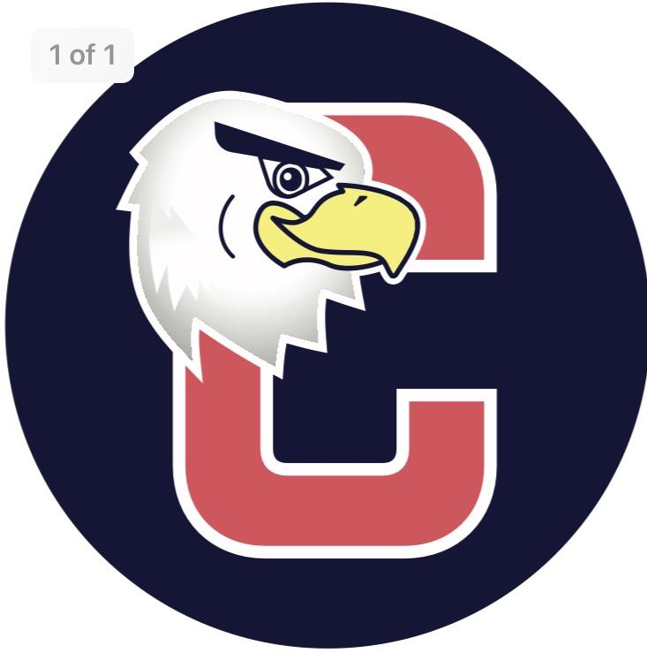
Cucinella PTO
General Membership Meeting Minutes
Monday, October 17, 2022
Attendance: Aimee Perhacs, Jen Campbell, Courtney Averyt, Melissa Svoboda, Liz Schwartz, Nicole Eckert, Kelli Pinnola, Nicole Weigel, Maureen Chlopik, Alyssa Nelson, Danielle Bayet, Michele Bires, Lisa Woodring, Jess Ingenito, Jess DeCicco, Jamie Bergen, Jessica Pricci, Toni Sturzebecker, Rita Turrin, Ashley Fortunato, Sheri Baker, Tara Trubela, John Hilly, Cassie Anderson, Lindsay Suchy, and Dominic Esposito
Virtual attendees: Leighann Day, Sarah Cipoletti, Danielle Campion, Erin Halpin, Lauren Palermo, Sarah VanBuzekom, Isabella Novaes, Laura Hunter, Mary Ann Walker, Megan Melofchek, Michelle King, Nicole, and Taryn Macones
Called to order at 7:01 pm.
- Pledge of Allegiance
- Courtney made a motion to accept the September minutes, Jaime 2nd, all in favor.
- Presidents Report
  - BOE Report – 7th grader earned golf award, bus safety, action plans for social emotional learning, link it, achievement in math and LA, STEM exp at LVMS 3/18 showcase, mobile app and 11/9 – NASA live inflight
  - Outdoor display case has all the PTO info
  - 10/28 6pm to 730 – Truck or Treat
  - Book Fair – 11/7 – 11/9 – looking for someone to shadow Marie and take over next year, also opportunities to volunteer
  - Theater week in January – 2nd to 5th grade can be involved
  - School closed 11/10 – 11/11
  - Holiday shoppe 12/14 – 12/16, Kristi is looking for help and holiday shoppers
  - Wepage updated new section “Volunteer to Help”
  - Reminder to sgin up for hubs in Memberhub
- Treasurer
a. Budget – yearbook line item – reducing prospective income from $1000 to $300. Courtney makes a motion to approve this change, and Aimee seconds it. All in favor

- Principal Report
  - Thank you for help on picture day
  - Thank for help on Fun Run
  - Week of respect – spirit days were a success. This Friday is dress like a super hero day.
  - Columbus Day professional Devleopment – teachers used LinkIt Program, data analysis and responsive classroom
  - Ms. Scrimo is new instrumental music program teacher
  - Stuff the bus donations due Oct 21st
  - Halloween – parade, parties, and dress up will be October 28th
  - Parent teacher conferences are coming in November. Classroom teachers will be sending out sign up geniuses.
  - Mr. Perusso sent out email today to teachers to submit PTO grant applications.
- Committee Reports
  - Membership
- 255 families signed up on Memberhub. 40 teachers
- Will be doing Memberhub cheat sheet
  - Assemblies/Programs
      - 11/3 – Yah-Oh-Way assembly – theme of Thanksgiving performed by the Thunderbird American Indian Dancers
  - Communications
      - Nellie Newsflash has all our info
      - Webpage update
      - Glow ring needed for Farm stand for Courtyard Garden. $367. Sarah makes a motion to purchase. Melissa seconds it. All in favor.

  - Fundraising/Events
      - Fun Run raised $22,584, $2200 matching gifts
      - Gertrude Hawk sale running now until 11/7
      - Ort Farm Pie sale running now until 11/9, pick up on 11/22 at Cucinella from 430 to 7
      - Spirit Wear Sale 10/26 – delivery 11/23
      - Silent Auction – spring 2023 – looking for committee members to start the planning process
  - Room Parent
      - Room parent checks are ready, please pick up
      - Family Fun Night – each grade will host 1
  - Teacher Appreciation
      - Will do a November treats cart with cider and donuts

- Unfinished Business

- New Business
      - BOE Candidates spoke
- Next Meeting is Monday, November 28, 2022
- Adjourn at 7:55

